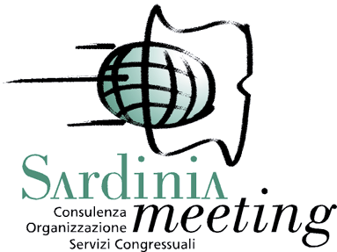
The Fourth International Renal Meeting with Mayo Clinic in Sardinia
Cagliari (Italy), April 30-May 3, 2017 Hotel Regina Margherita

To be completed and sent to the Organizing Secretariat:

SARDINIAMEETING Srl - Viale La Playa, 7 - 09123 Cagliari - info@sardiniameeting.it -
Fax +39 070 6406641 - Ph.+39 070 664334
REGISTRATION FORM

FAMILY NAME ________________ __FIRST NAME_______________________________________________

DATE AND PLACE OF BIRTH_____________________________________________________________________________________________

VAT/TAX CODE _____ __________________________________________________________________________________

ADDRESS _____________________________________________________________________________________________________________

CITY __________ ____________ ______ ZIP CODE _______ ____________________________

PHONE NR. _ ___ MOBILE PH. ____ ____________

EMAIL______________________ __________________

PROFESSION SPECIALIZATION_ GRADUATE STUDENT_ □ ________

INSTITUTION_______________________________ _____________________________________PH. ____________

FOR ITALIAN PARTICIPANTS:

Barrare la casella di pertinenza: □ DIPENDENTE □ CONVENZIONATO □ LIBERO PROFESSIONISTA □ PRIVO DI OCCUPAZ.

REGISTRATION FEES

Registration | € | No. of  people | Total in €
Medical Doctor | 280,00
Resident | 130,00
Student | Free of charge

The registration fee includes: conference materials, 2 coffee breaks, 2 working lunches, social dinner.

SUM TO BE PAID _____________________________________ (all prices are in Euro VAT included)
- Bank transfer to SARDINIAMEETING SRL, Banco di Sardegna – Ag.1 Cagliari
IBAN IT61Y0101504801000070473655 Swift/BIC code: BPMOIT22 XXX
Please specify: Participant's name + The Fourth International Renal Meeting with Mayo Clinic in Sardinia 2017

- Cash/POS device at Sardiniameeting Srl – Viale La Playa, 7 – Cagliari
- Bank Draft n ………….………………….. Bank…………………………………………. € ……………………
addressed to: Sardiniameeting Srl Viale La Playa, 7 - 09123 Cagliari

Please note: a copy of the payment should be faxed or sent by email together with the registration form.

The invoice must be addressed to (if different from above):

Company name or Full name__________________________________________________________________________________

VAT registration number ________________________________________ Fiscal code (if any) _____________________________

Address_____________________________________________________ City __________________________________________

State/Province ______________________ Postal/Zip code ______________ Country ____________________

Personal data handling In accordance with Italian Law No. 196/2003 we hereby declare that any personal information in our possession will be used only for the purposes of the meeting.

Date………………………… Signature…………………………..…………

